**Team ID :** NM2025TMID17674

**Team Leader :** PONMALAR M

**Team member :** PADMA PRIYA S

**Team member :** PAVITHRA J

**Team member :** POOJA A

**Team member :** POOJA S

### Problem Statement: Educational Organisation Using ServiceNow

### Objective: The Educational Management System is a comprehensive platform designed to streamline administrative tasks within educational institutions. It facilitates efficient management of student and teacher data, simplifies the admission process, and provides tools for monitoring student progress.

### TASK INITIATION

### Milestone 1 : Creating a Update Set.

1. Click on All >> Local update sets .

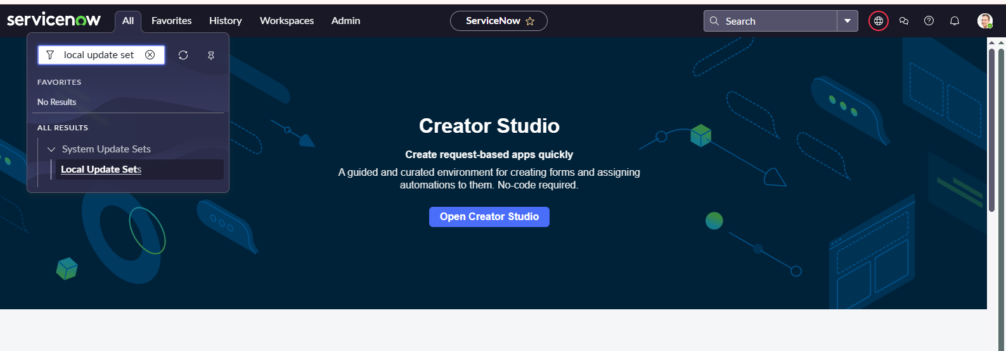

1. Click on new
2. Enter the Details Name: Educational Organisation >> Click on Submit and make Current.

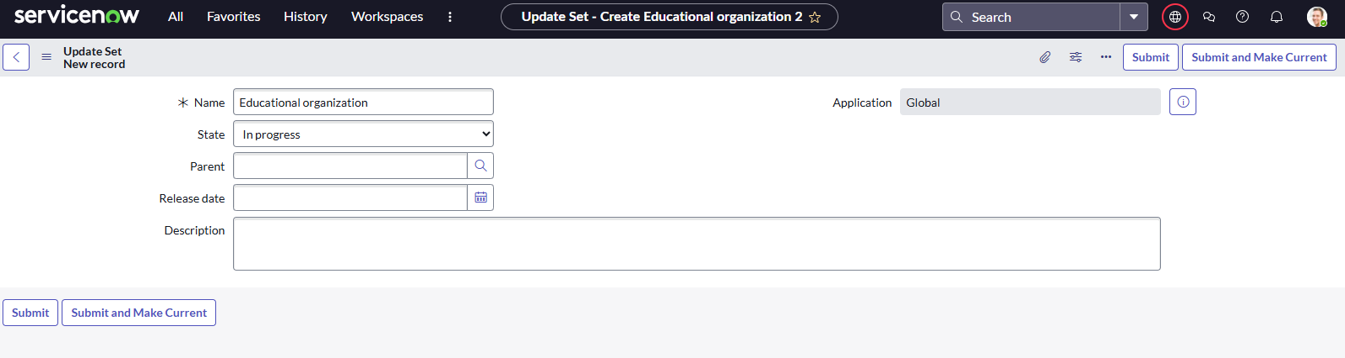

### Milestone 2 : Creating a Table

* All >> Tables.

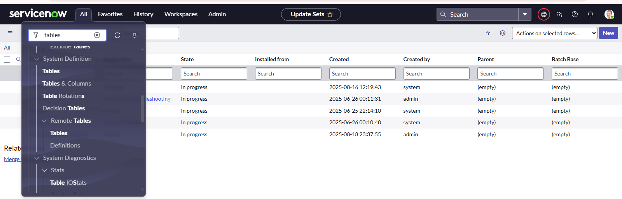

* Click on new
* Enter the Label Edtect Program >> Click on Name it will Automatically generate Api name.

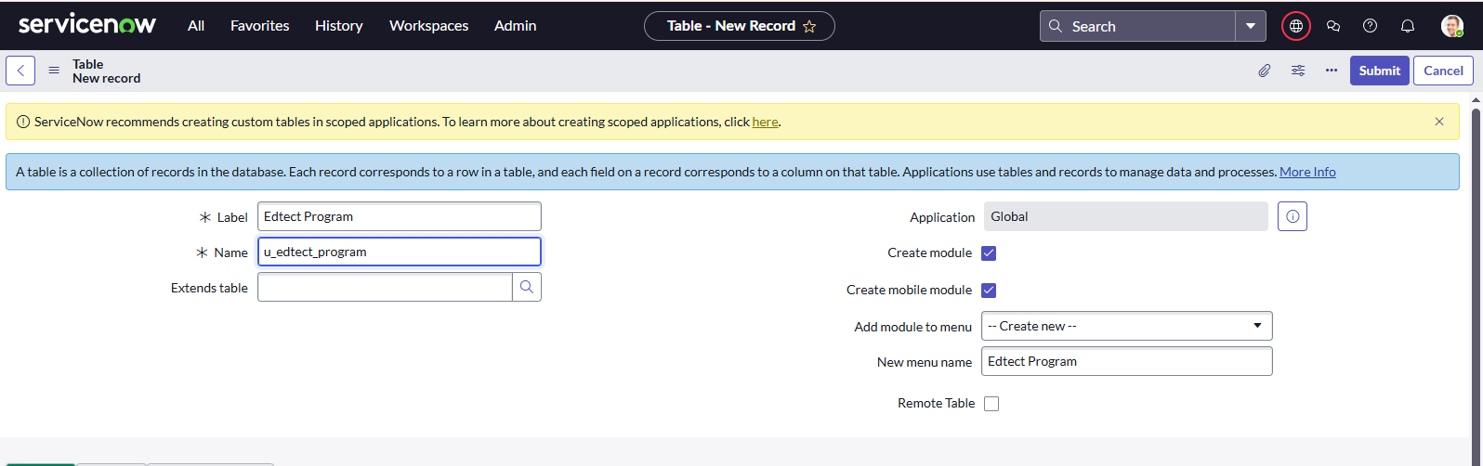

* Create columns as given below,Double Click on Column label and Enter the Column labels and click on the tick mark >> Give Type as given .

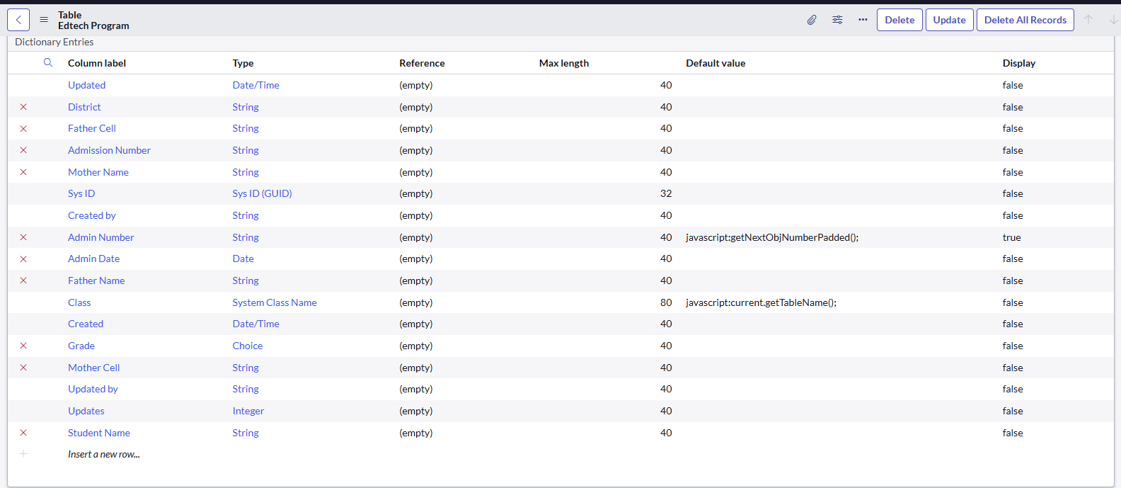

* For “Admin Number” Give Display as True and right click on the toggle bar on top >> save.
* Click on controls >> Enable Extensible.
* Click on “Admin Number” column, In Related Links Click on Advanced View >> Default View (Enable Use dynamic default) >> select Get Next Padded Number in Dynamic default value >> Update .
* Click on “Grade” Column >> Click on Choices and give Label,Value and Sequence as given below.

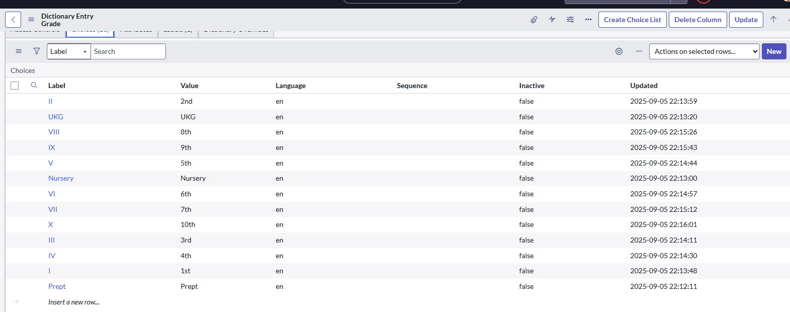

Create one more Table

* Create an Admission Table with Columns given.
* Select Extends Table >> Edtect Program also Select Add module to menu >> Edtect Program.
* Create Fields as shown

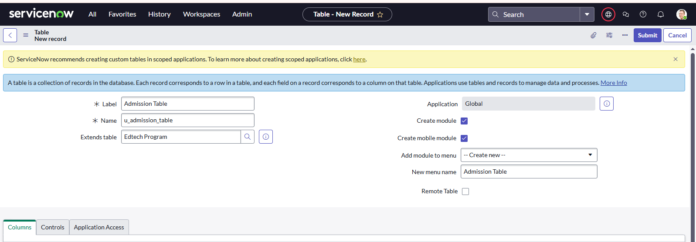

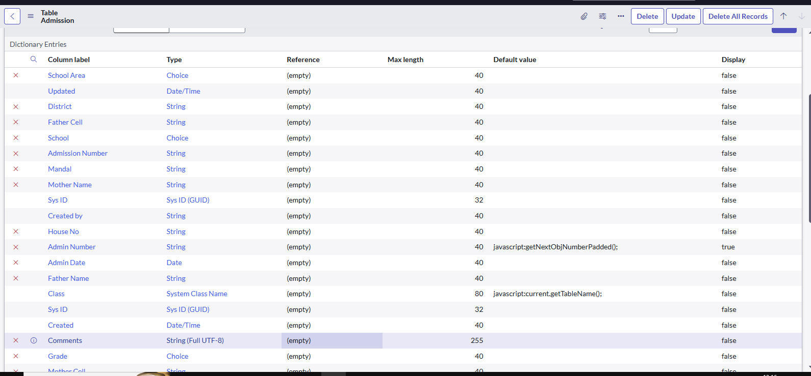

* Create choice for Admin Status as:

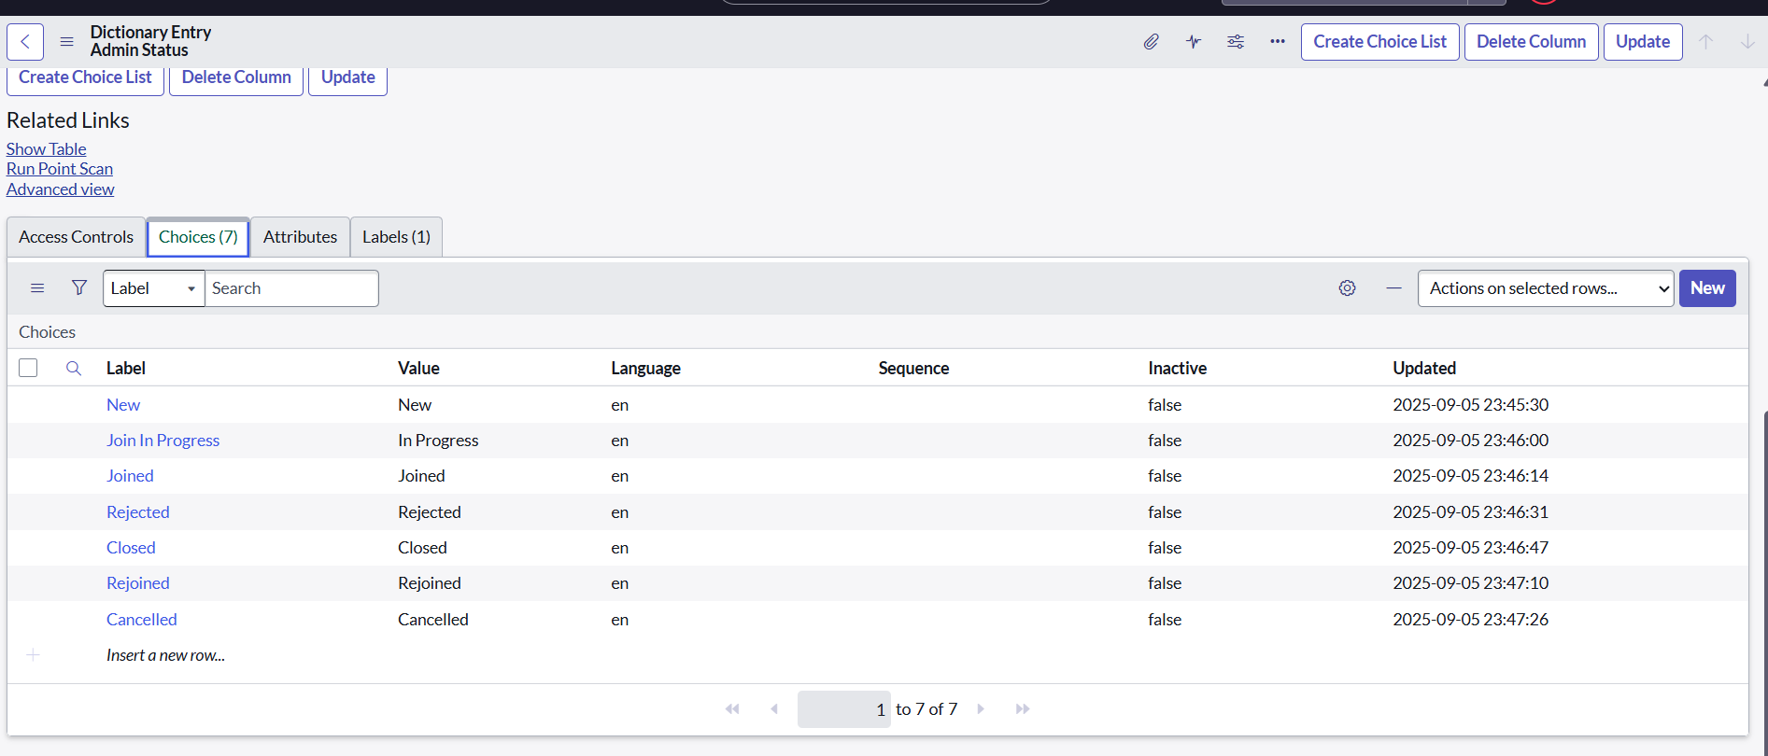

* Create choice for Pincode as:

* Create choice for Purpose of Join as:

* Create choice for School as:

* Create choice for School Area as:

Create one more Table

* Create a Student Progress Table with Columns given.
* Select Add module to menu >> Salesforce.
* Create Fields as shown:

**Milestone 3 :** **Form Layout**

* In the Student Progress Table Page , Click on Layout form .
* Click on Admission Number [+] .
* Select below Admission Number fields in Available side and send it to selected side as below >> save.

**Milestone 4 : Form Design**

1. All >> System Definition >> Tables .
2. In Label Search for Edtech Program and open
3. Right Click on top Toggle >> Configure >> Form Design.
4. In drop down select Edtech Program(u_edtech_program)
5. Drag and drop the fields to the left side as below.

Create one more Form Design

Creating Form Design for Admission Table

Follow the same steps as Activity1,Configure the fields as below and Save.

Create one more Form Design

Creating Form Design for Student progress Table

Follow the same steps as Activity1,Configure the fields as below and Save.

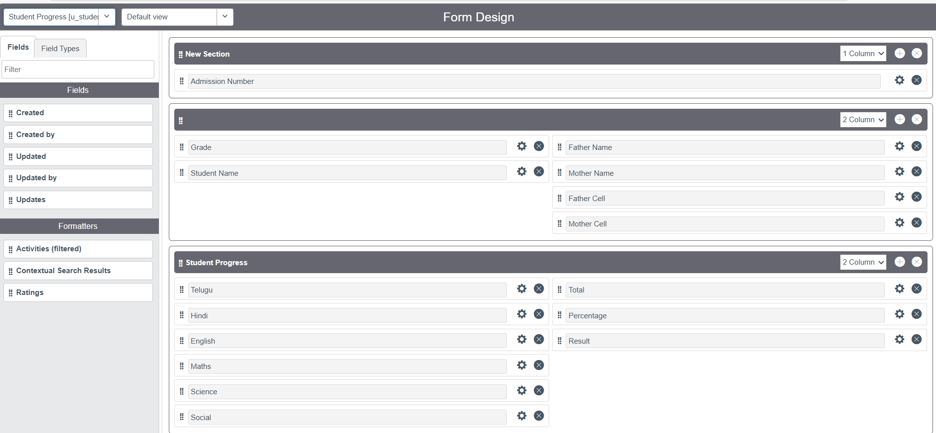

**Milestone 5 : Number Maintenance**

* All >> Number Maintenance >> New
* Fill the details >> Submit.

**Milestone 6 : Process Flow**

* All >> Process Flow>> New.
* Fill the Details as given Below

* Right Click on toggle and click on the save .
* Replace the Name and Label as below and click on Insert on stay.
* Replace the Name and Label in order and click on Insert on stay.

Joined >> Rejected >> Rejoined >> Closed >> Cancelled.

* Order should be New >> InProgress >> Joined >> Rejected >> Rejoined >> Closed >> Cancelled.

**Milestone 7 : Client Script**

Creating “Auto populate” Client Scripts for Admission Table

* All >> Client Scripts >> New.
* Fill the Details as given.

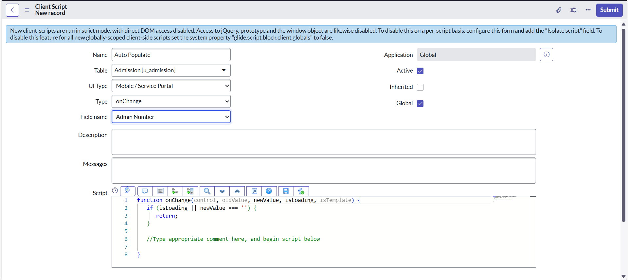

* Write the Code as below, Enable Isolate script and Save.

function onChange(control, oldValue, newValue, isLoading, isTemplate) {

   if (isLoading || newValue === '') {

      return;

   }

   //Type appropriate comment here, and begin script below

   var a = g_form.getReference('u_admission_number');

   g_form.setValue('u_admin_date',a.u_admin_date);

   g_form.setValue('u_grade',a.u_grade);

   g_form.setValue('u_student_name',a.u_student_name);

   g_form.setValue('u_father_name',a.u_father_name);

   g_form.setValue('u_mother_name',a.u_mother_name);

   g_form.setValue('u_father_cell',a.u_father_cell);

   g_form.setValue('u_mother_cell',a.u_mother_cell);

   g_form.setDisabled('u_admin_date',a.u_admin_date);

   g_form.setDisabled('u_grade',a.u_grade);

   g_form.setDisabled('u_student_name',a.u_student_name);

   g_form.setDisabled('u_father_name',a.u_father_name);

   g_form.setDisabled('u_mother_name',a.u_mother_name);

   g_form.setDisabled('u_father_cell',a.u_father_cell);

   g_form.setDisabled('u_mother_cell',a.u_mother_cell);

}

Create one more Client Script

Creating “Pincode Update” Client Scripts for Admission Table

* Fill the Details as given.

* Write the Code as below, Enable Isolate script and Save.

function onChange(control, oldValue, newValue, isLoading, isTemplate) {

   if (isLoading || newValue === '') {

      return;

   }

    var a = g_form.getValue('u_pincode');

if(a == '509358')

{

g_form.setValue('u_mandal', 'kadthal');

g_form.setValue('u_city', 'kadthal');

g_form.setValue('u_district', 'RangaReddy');

}

else if(a == '500081')

{

g_form.setValue('u_mandal', 'karmanghat');

g_form.setValue('u_city', 'karmanghat');

g_form.setValue('u_district', 'RangaReddy');

}

else if(a == '500079')

{

g_form.setValue('u_mandal', 'Abids');

g_form.setValue('u_city', 'AsifNagar');

g_form.setValue('u_district', 'Hyderabad');

}

   //Type appropriate comment here, and begin script below

}

Create one more Client Script

Creating “Disable Fields” Client Scripts for Student progress Table

* Fill the Details as given.

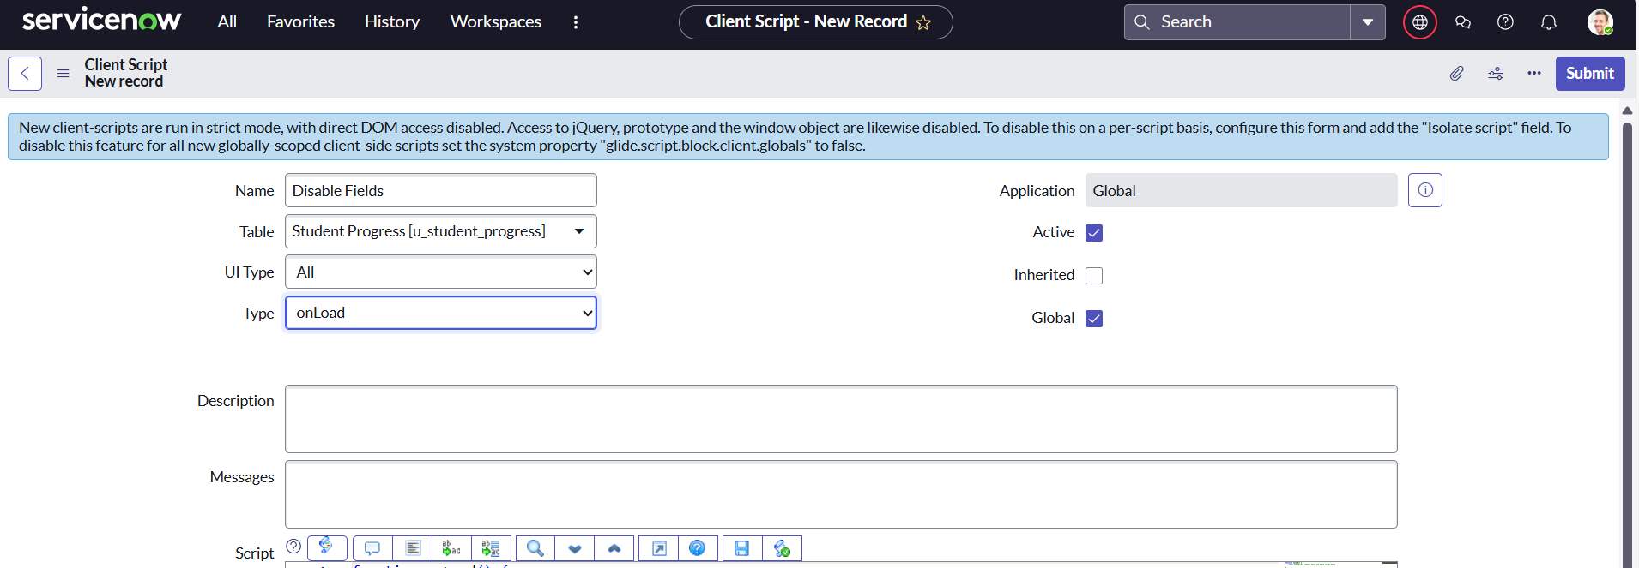

* Write the Code as below, Enable Isolate script and Save.

function onLoad() {

   //Type appropriate comment here, and begin script below

   g_form.setDisabled('u_total',true);

   g_form.setDisabled('u_percentage',true);

   g_form.setDisabled('u_result',true);

}

Create one more Client Script

Creating “Total Update” Client Scripts for Student progress Table

* Fill the Details as given.

* Write the Code as below, Enable Isolate script and Save.

function onChange(control, oldValue, newValue, isLoading, isTemplate) {

   if (isLoading || newValue === '') {

      return;

   }

   //Type appropriate comment here, and begin script below

if (newValue){

var a = parseInt(g_form.getValue('u_telugu'));

var b = parseInt(g_form.getValue('u_hindi'));

var c = parseInt(g_form.getValue('u_english'));

var d = parseInt(g_form.getValue('u_maths'));

var e = parseInt(g_form.getValue('u_science'));

var f = parseInt(g_form.getValue('u_social'));

var Total = parseInt(a+b+c+d+e+f);

g_form.setValue('u_total', Total);

}

}

Create one more Client Script

Creating “Result” Client Scripts for Student progress Table

* Fill the Details as given.

* Write the Code as below, Enable Isolate script and Save.

function onChange(control, oldValue, newValue, isLoading, isTemplate) {

   if (isLoading || newValue === '') {

      return;

   }

   //Type appropriate comment here, and begin script below

   if(newValue) {

      var a = parseInt(g_form.getValue('u_percentage')); // Convert the value to an integer for comparison

      if(a >= 0 && a <= 59){

         g_form.setValue('u_result','Fail');

      } else if(a >= 60 && a <= 100) {

         g_form.setValue('u_result','Pass');

      } else {

         // Handle the case if a is out of range (optional)

         g_form.addErrorMessage('Percentage should be between 0 and 100.');

         g_form.clearValue('u_result');

      }

   }

}

Create one more Client Script

Creating “Percentage” Client Scripts for Student progress Table

* Fill the Details as given.

* Write the Code as below, Enable Isolate script and Save.

function onChange(control, oldValue, newValue, isLoading, isTemplate) {

   if (isLoading || newValue === '') {

      return;

   }

   //Type appropriate comment here, and begin script below

   var Total = g_form.getValue('u_total');

   var Percentage = (Total/600)*100;

   g_form.setValue('u_percentage',Percentage+'%');

}

**Result**

